|  |
| --- |
| Confederated Tribes of the Umatilla Indian Reservation |
| DNR Data Management Maturity Model |
| Introducing the Maturity Model Improvement Process |

|  |
| --- |
| Ken Burcham & Colette Coiner, OIT  3/18/2013 |

**INTRODUCTION**

There is currently a strategic opportunity in the Department of Natural Resources (DNR) to help relieve the growing administrative burden of managing data. From December 2012 to March 2013, OIT/GIS staff reviewed the six DNR Programs and found that more than 200 different datasets are being actively collected by scores of teams and individuals. These datasets represent an enormous and growing amount of data with increasingly complex internal and external reporting needs, standards requirements, and sharing requests. We suggest that by centralizing, organizing and standardizing the data collection processes and technologies, everyone from project leads, managers and individual tribal members will benefit.

As part of our initial review, we characterize DNR Data Management “maturity” and propose to use the "Data Collection Maturity Model" below to capture the current and desired future state for DNR data management. The Maturity Model breaks the improvement process down into five levels and provides clear benchmarks for measuring our progress as well as anticipating organizational impact. In the model we identify "Key Drivers" of maturity that most contribute to the successful outcomes we desire.

**MODEL PROGRESSION**

A Maturity Model is a two-dimensional shows improvement and transformation of a business or organization over time. In Figure 1, the temporal dimension shows a progression from the present time to a realistic future time. The spatial dimension captures how the business looks and what capabilities it exhibits at each progressively higher maturity level[1]. This Maturity Model could be applied to any organizational unit in CTUIR wishing to structure improvement, but here we specifically apply it to data management in DNR.

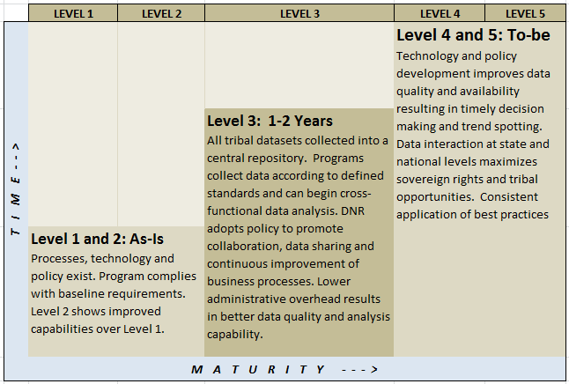

*Figure 1: Overview of the DNR Data Collection Maturity Model*

In our case, Level 1 and 2 represent our current state: DNR does collect data, and lots of it! And that data is considered to be compliant with all current funding and organizational requirements. Some projects demonstrate aspects of Level 2 which provide improvement over Level 1. The central column represents a look ahead into the next 1-2 years where we want to find ourselves using a central repository for datasets that enable all kinds of capabilities that are currently out of reach. Beyond that, into Levels 4 and 5, we see substantial increases in capacity and scope allowing the organization to leverage DNR information for maximum benefit.

**MATURITY LEVEL CHARACTERISTICS**

Each of the five levels in the Maturity Model reflects certain characteristics. Figure 2 lists the attributes that can be used to describe each level. As we move from left to right (Level 1 to Level 5) each successive Level's characteristics represent a substantial improvement in order and capacity. These labels are not exhaustive, merely suggestive of the behavior, tools and processes in use at each level.

|  |  |  |  |  |
| --- | --- | --- | --- | --- |
| **Figure 2: Maturity Level Characteristics** | | | | |
| ***Level 1*** | ***Level 2*** | ***Level 3*** | ***Level 4*** | ***Level 5*** |
| Ad Hoc  Undocumented  Individual Heroics  Dynamic  Reactive | Some repeatable  Some consistency  Some disciplines | Defined  Documented  Standards  Consistency | Process metrics  Controlled process  Adaptable process  Consistent results | Incremental  Innovative  Improvements |

As we apply the Maturity Model's characteristics to DNR Data Management practices, we can articulate the specific behaviors that represent improvements at each level. Figure 3 takes us a step deeper into the specific improvements each Level has over the previous Level for DNR Data Management.

|  |  |  |  |  |
| --- | --- | --- | --- | --- |
| **Figure 3: DNR Data Collection Maturity Levels**  *For generic DNR Program (i.e. Water Resources, Fisheries, Wildlife…)* | | | | |
| ***Level 1*** | ***Level 2*** | ***Level 3*** | ***Level 4*** | ***Level 5*** |
| ● Program meets basic  requirements  ● Variety of manual  collection methods  ● Manual transcription  ● Various tools (Excel,  Access, web)  ● Manually created  analysis & reports  ● Manual publishing  and data sharing  ● Project-wide  standards usually  applied | ● Data centrally  stored, backed up  ● Some automated  collection methods  ● Some reporting  automation  ● Program-wide  data standards  consistently applied  ● Centralized data  storage and sharing  ● Some QA  methodologies  employed | ● Program applies  DNR-wide standards  uniformly  ● Data mostly  electronically captured  ● Centralized Data  Management System  ● Cross-functional  analysis possible  ● Report automation  ● Consistent, high-  quality, visible data  ● Improved organ-  izational decision  support systems  ● Automated publish | ● Mobile, sensor  connected data  collection routine  ● Analysis reports  fully automated  ● Ad-hoc cross-  functional queries  ● Timely and  transparent  information enables  actionable data  ● Integrate with  other systems via  bi-directional data-  sharing agreements  ● Increased capacity | ● Business Intelligence  and Decision Support  Systems employed for  trend analysis  ● State/National  standards (as  adopted)  ● Maximize sovereign  rights  ● New capabilities  ● Innovation  ● Data-informed  decisions benefit  greatest number of  tribal members |

As we move from left to right (Level 1 to Level 5) each successive Level represents a substantial improvement in order and capacity:

Level 1 🡪 Level 2 involves centralizing and consolidating files to a backed up location, automating reports and consistently applying QA methodologies, etc.

Level 2 🡪 Level 3 moves to standardized data collection practices with data stored in a central database. This allows for queries across datasets and projects as well as automated report generation.

Level 3 🡪 Level 4 completes the formalization process and provides infrastructure for mobile and automated data collection and publishing.

Level 4 🡪 Level 5 increases scope from tribal data only to consumption of State and National data for analysis. Enterprise decision support systems now can come into play.

To move from one level to another necessitates substantial commitment because different kinds of inputs are required. These can include policy changes, new infrastructure, definition of standards, new accountability structures, metrics, tools, training, etc. Only when these resources and organizational fortitude come together is enough traction present to bring about the next state of maturity. However, it is important to realize that not all processes above are necessarily linear; for example it is even possible (as we did in the overview) to roughly group together Levels 1 and 2. But recognize that each Level represents the characteristics at that Level of maturity.

At this point, it could be beneficial to look at each individual DNR Program and/or Project and rate the individual Maturity Level in a manner such as the following:

|  |  |  |  |  |  |
| --- | --- | --- | --- | --- | --- |
| **DNR Program** | **Figure 4:**  **DNR Program Maturity Level** | | | | |
| 1 | 2 | 3 | 4 | 5 |
| Admin |  |  |  |  |  |
| CRPP |  |  |  |  |  |
| Water Res |  |  |  |  |  |
| Fisheries |  |  |  |  |  |
| Wildlife |  |  |  |  |  |
| Range/Ag |  |  |  |  |  |
| Forestry |  |  |  |  |  |
| FFPP |  |  |  |  |  |

However, during the DNR Dataset Assessment process, we realized that without formal and written Data Field standards, Data Collection standards and a centralized Data Management System in place, as well as the policies and training necessary to implement them, only a Level 2 Maturity Level is possible. At this point, then, all DNR Programs are at a Level 1 or Level 2 and further distinction isn't that helpful. Later, it will be helpful to use Figure 4 to measure progress.

The next step is then to articulate the specific, measurable improvements necessary to move a Program from one level of maturity to the next. Figure 5 lists these "Key Drivers" we identified as essential areas of improvement on the left hand axis, with what qualities or characteristics are present at each Level of maturity across the top.

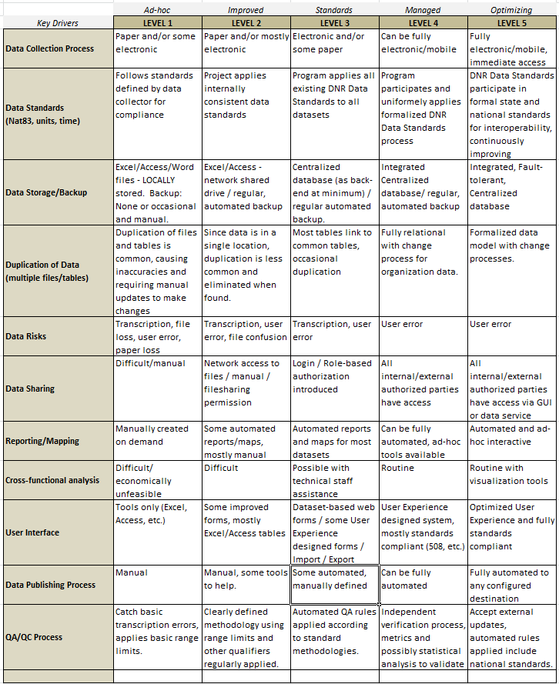

*Figure 5: DNR Data Collection Maturity Model Matrix*

To use the matrix to measure the maturity improvements of the Data Collection practices of a particular dataset, select either an individual dataset being actively managed in a DNR program or perhaps a set of datasets belonging to a particular project that are all managed according to the same practices and with the same tools. Consider each "Key Driver" for the dataset.

For example, we might ask: What is the "Data Collection Process" employed for this dataset in question? Is the process to use paper field sheets to record everything including latitude and longitude? It probably comes in at a Level 1 rank. Is the data collected according to the DNR Data Standards for the project? Or are some datasets collected in degrees F and others in degrees C? Perhaps we assign it a Level 2 for that key driver. Finally, is the data entered into a number of different Excel files stored on the local computer or is there a consolidated file stored on a backed up network drive? Given the answer, perhaps we rank it at Level 1, and so on.

Thus, by using the Maturity Model above, we can measure our progress across these Key Drivers and demonstrate specific improvements over time toward our goal of organizational maturity.

**BENCHMARKS FOR IMPROVEMENT**

In our estimation, after a lengthy DNR interview process, nearly all datasets are at a Level 1 or Level 2 overall maturity level for almost all of the key drivers. In our overview, we identify LEVEL 3 as our 1-2 year goal because we recognize that without LEVEL 3 scale improvements, the growing administrative overhead for collection and reporting will outstrip staff capacity and limit organizational capability. The maturity model articulates an answer to the question: "What will be necessary to move from an overall Level 1/2 to Level 3?" by providing measurable indicators in the behaviors critical for maturity improvement.

We have identified the following "Key Drivers" to be pivotal for attaining Level 3 maturity:

|  |  |  |
| --- | --- | --- |
| ***Key Driver*** | ***Description of Activity*** | ***Who is responsible*** |
| Data Field Standards | Develop formal DNR-wide Data Field Standards for all collected data fields (units, time zones, map schemas, etc.) to make uniform, centralized data collection and queries possible. | OIT,  DNR Project Leads |
| Data Collection Standards | Develop formal DNR-wide Data Collection policies and procedures. | OIT,  DNR Project Leads |
| QA/QC Process | Develop formal DNR-wide QA/QC methodology and practices to best safeguard data quality and to allow for uniform application of QA rules. | OIT,  DNR Project Leads |
| Project/Data Tracker Application | Develop a web-based Project/Data tracker Data Management Application that can act as a central repository for all datasets, apply standard field definitions and validation rules, provide QA tools and rules and automate report, map and publish features. | OIT,  with significant DNR Project Lead assistance |
| Policies, training, and culture modification | Provide necessary context to bring about this transformation. | DNR Director,  OIT Director |

**ORGANIZATIONAL IMPACT**

These standards and tools will have direct, positive organizational impacts. The following Logic Model diagram demonstrates the Inputs, Outputs, Outcomes and Impact we anticipate.

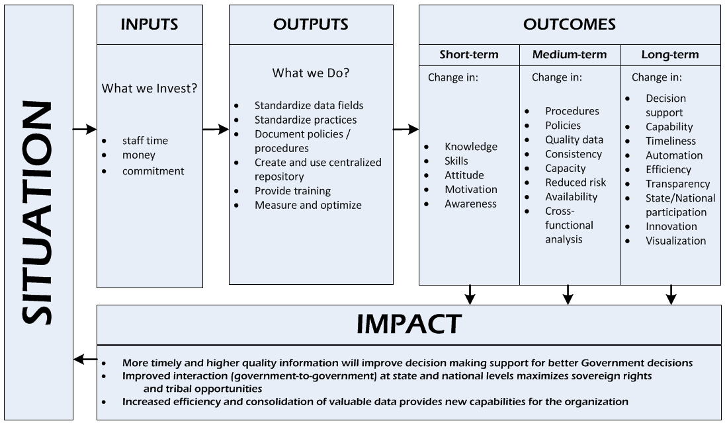

**CONCLUSION**

Growth always brings challenges and DNR Data Collection and Management are no different. Now that so much data is collected in so many ways, we need to provide more structure and standards to prepare for the next stage of increasing DNR's capacity. By defining DNR-wide data field standards, QA and data collection processes we can create a Data Management Application that can house all DNR datasets and begin providing automation and cross-functional query and reporting capabilities. Since DNR plays such an integral part in providing data-oriented information for tribal decision making (including and especially the First Foods initiative), these improved policies, practices and tools will bring about compelling organizational outcomes and impacts.

:Appendix 1: Organizational Maturity Levels [2]

|  |  |  |  |  |  |
| --- | --- | --- | --- | --- | --- |
|  | Level 1  Performed | Level 2  Managed | Level 3  Established | Level 4  Predictable | Level 5  Optimizing |
| People | Success depends on individual heroics.  “Fire fighting is a way of life.”  Relationships between disciplines are uncoordinated perhaps even adversarial. | Success depends on individuals and management system supports.  Commitments are understood and managed.  People are trained. | Project groups work together, perhaps as an integrated product team.  Training is planned and provided according to roles. | A strong sense of teamwork exists within each project. | A strong sense of teamwork exists across the organization.  Everyone is involved in process improvement. |
| Process | Few stable processes exist or are used. | Documented and stable estimating, planning, and commitment processes are at the project level. | Integrated management and engineering processes are used across the organization. | Processes are quantitatively understood and stabilized. | Processes are continuously and systematically improved. |
| Technology | The introduction of new technology is risky. | Technology supports established, stable activities. | New technologies are evaluated on a qualitative basis. | New technologies are evaluated on a quantitative basis. | New technologies are proactively pursued and deployed. |
| Measurement | Data collection and analysis are ad hoc. | Planning and management data is used by individual projects. | Data is collected and used in all defined processes.  Data is systematically shared across projects. | Data definition and collection are standardized across the organization  Data is used to understand the process qualitatively and stabilize it. | Data is used to evaluate and select process improvements. |

SPICE Criteria Levels[3]

| Level | Level Name | Capability Level Description |
| --- | --- | --- |
| 0 | Incomplete | There is a general failure to attain the purpose of the process. There are no easily identifiable work products or outputs of the process. |
| 1 | Performed | The purpose of the process is generally achieved. The achievement may not be rigorously planned and tracked. Individuals within the organization recognize that an action should be performed, and there is general agreement that this action is performed as and when required. There are identifiable work products for the process, and these testify to the achievement of the purpose. |
| 2 | Managed | The process delivers work products of acceptable quality within defined time scales. Performance according to specified procedures is planned and tracked. Work products conform to specified standards and requirements. |
| 3 | Established | The process is performed and managed using a defined process based upon good principles. Individual implementations of the process use approved, tailored versions of standard and documented processes. The resources necessary to establish the process definition are also in place. |
| 4 | Predictable | The defined process is performed consistently in practice, within defined control limits, to achieve its goals. Detailed measures of performance are collected and analyzed. This practice leads to a quantitative understanding of process capability and an improved ability to predict performance. The quality of work products is quantitatively known. |
| 5 | Optimizing | Performance of the process is optimized to meet current and future business needs, and the process achieves repeatability in meeting its defined business goals. Quantitative process effectiveness and efficiency goals (targets) for performance are established, based on the business goals of the organization. Obtaining quantitative feedback enables continuous process monitoring against these goals, and improvement is achieved by analysis of the results. Optimizing a process involves piloting innovative ideas and technologies and changing non-effective processes to meet defined goals and objectives. |

From ‘Microsoft Readiness Framework Organizational Readiness White Paper

1. The MITA Maturity Model as accessed 1/18/2013 from http://medicaid.gov/Medicaid-CHIP-Program-Information/By-Topics/Data-and-Systems/Downloads/mitamm.pdf
2. From: <http://www2.slac.stanford.edu/comp/winnt/system-administration/Organizational%20Maturity%20Levels.doc> as viewed 2/12/2013
3. Levels 1 to 5 can be applied to an organization to determine its level of maturity in relation to people, process, technology, and measurement.